Web Engineering
Lab Task 5

- Design and Create Replica Web page for the following Link by using HTML, CSS and Bootstrap 5 Classes.
  - https://www.daraz.pk/#
  - Daraz Complete Index/ Home Page only
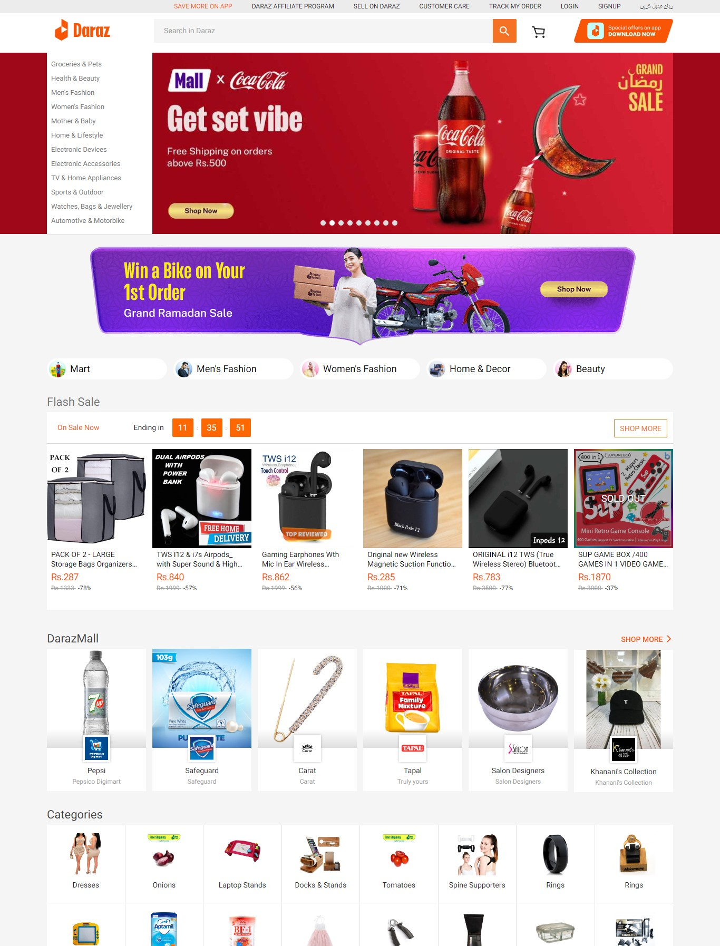

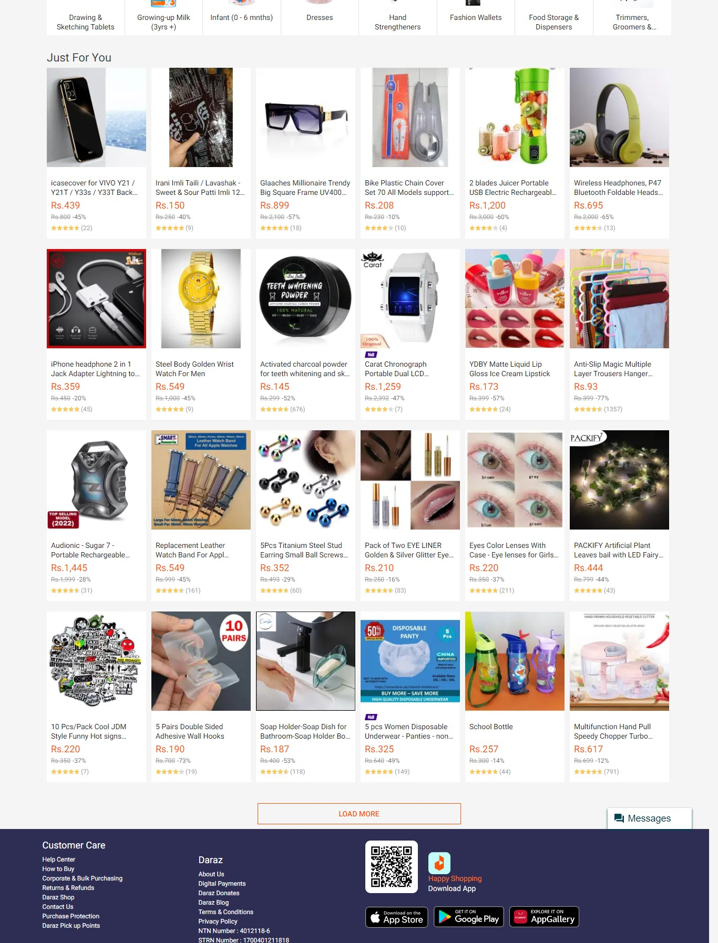

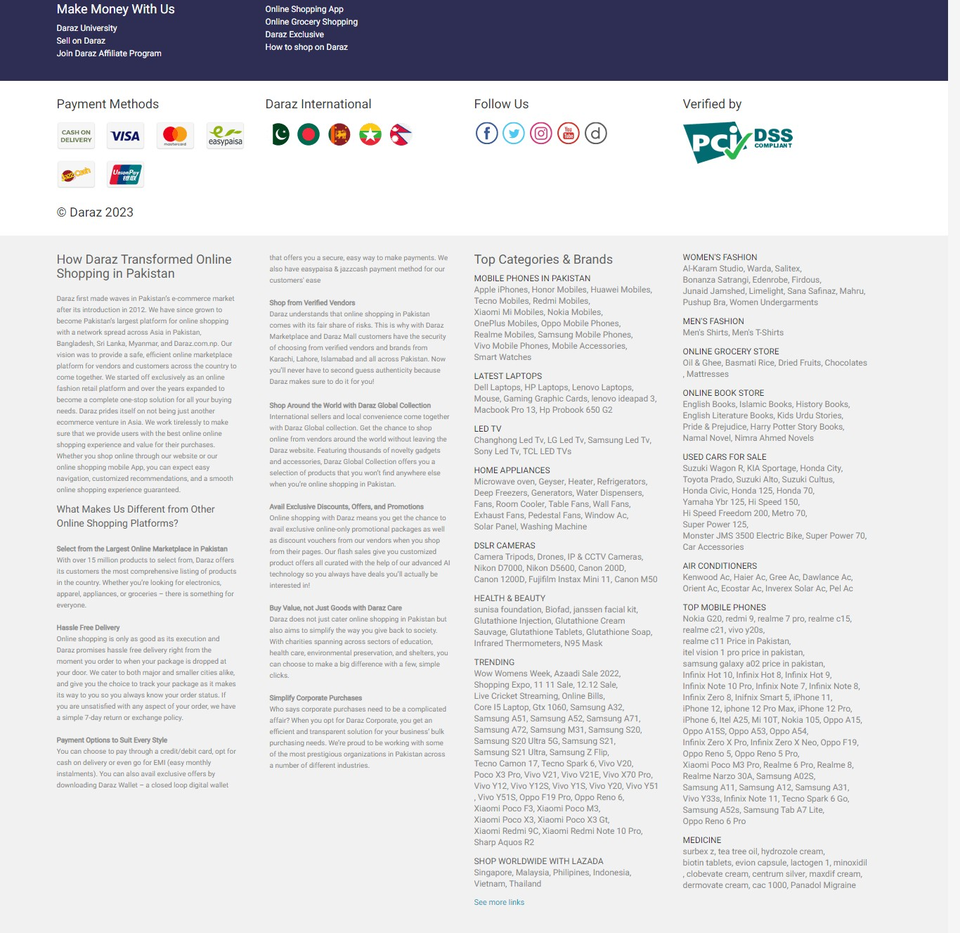

Submission:
- You have Submit Complete Folder Zip file on Slate containing
  - HTML files
  - Media files
  - CSS file (external)

